**Design of the Experiment**

**Between-subjects design:**

**Design**: 2 (*CS-US color matching:* CS1[CS2] symbolically sharing a color with positive[negative]USs vs. CS2[CS1] symbolically sharing a color with positive[negative]USs) between-subject design. Method factors varied between participants:

* + - *CS color assignment*: CS1/CS2 assigned to symbolic color match with positive/negative words
    - *Order of evaluative measures*: IAT before vs. after self-reports
    - *IAT block order* (consistent vs. inconsistent with learning phase).

**Stimuli.** Two nonsense words (MORAG and STRUAN) will serve as CS1 and CS2. Six positive (*Rainbow, Pleasure, Smile, Love, Paradise, Joy*) and six negative adjectives (*War, Cancer, Hate, Hell, Misery, Vomit*) will serve as USs.  
**Participants.** Data-collection will be via the Prolific website (prolific.achttps://prolific.ac/). We will stop data-collection as soon as 200 participants have completed the experiment on the Prolific website. This will allow us to have good power (> 0.80) to observe an EC effect (*d* = 0.50) driven by US-CS color matching, at alpha = 0.05.

**Procedure.** Color Training 🡪 EC 🡪 Evaluative measures 🡪 Exploratory Questions

*Color Training.* A simplified Matching to Sample (MTS) procedure will be used to establish a relationship between different colors. On each trial, one color will be presented at the top of the screen, and two at the bottom. Participants will have to select the color at the bottom that goes with the color at the top. If they are correct, all stimuli will be removed from the screen, a feedback message (‘Correct’) will appear, followed by a 500ms inter-trial interval. If they make an error, the same trial progression will occur, but the feedback message will differ (‘Wrong’). Participants will complete three blocks of 16 training trials, followed by one block of 16 test trials. The only difference between training and testing is that no corrective feedback is provided on the latter.

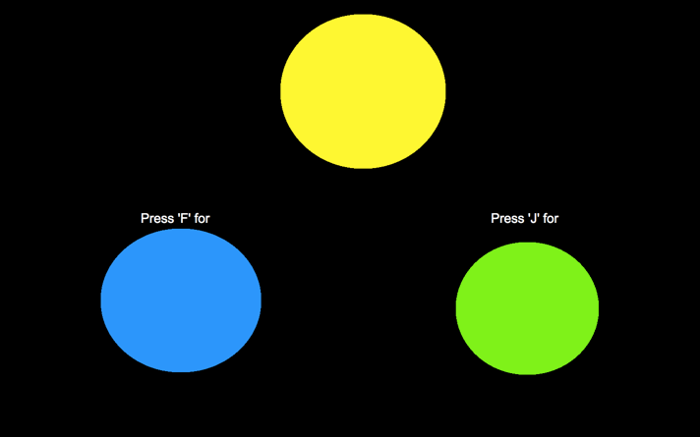

*EC training phase*. Participants receive three blocks of 16 trials (48 total) consisting of two different types of trials. In one type of trial CS1 will be presented in BLUE, positive words in YELLOW, and negative words in PURPLE. In another type of trial CS2 will be presented in GREEN, and the valenced words will be presented in the colors mentioned above. Note that each trial will contain three stimuli simultaneously presented onscreen: a neutral word (MORAG or STRUAN) and positive and negatively valenced words. All three stimuli will initially be presented for 5000ms, after which all stimuli will be removed, followed by an inter-trial interval of 750ms, and the next trial. Four different colors (i.e., blue, green, yellow and purple) will be used and assignment of the colors will be counterbalanced across CSs.

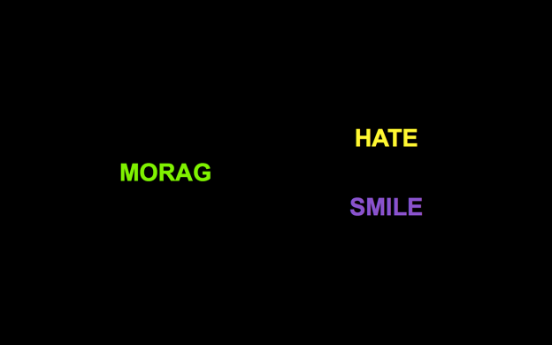 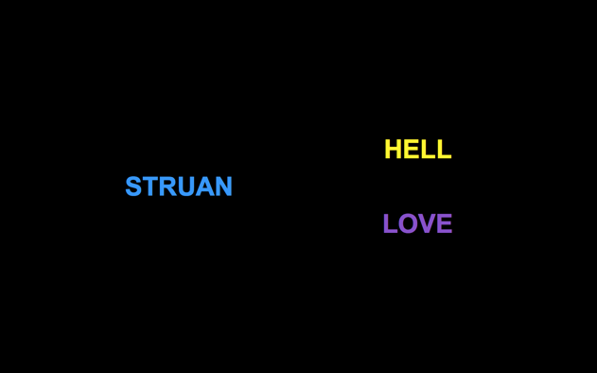

*Implicit attitude*

Participants will perform an IAT measuring implicit evaluations of CS1 vs. CS2:   
The IAT involves the categories “CS1” and “CS2” and “Good” and “Bad”  
  
IAT Procedure:

a. Instructions: “In the next part you will have to categorize items into groups as fast as you can.”

b. 20 practice trials sorting CS1 on the left and CS2 on the right.   
  
c. 20 practice trials sorting positive words on the left and negative words on the right.

d. 20 test trials CS1 and positive words using one key and CS2 and negative words using another key.

e. 40 test trials CS1 and positive words using one key and CS2 and negative words using another key.

f. 20 practice trials CS2 on the left and CS1 on the right.

g. 20 test trials CS2 and positive on the left and CS1 and negative on the right.

h. 40 test trials CS2 and positive on the left and CS1 and negative on the right.

NOTE: IAT stimuli are:

* + - CS1
    - CS2
    - Positive words: *Fantastic, Great, Nice, Good, Pleasant, Wonderful, Amazing, Happy*
    - Negative words: *Terrible, Disgusting, Nasty, Horrible, Sick, Awful, Sad, Unpleasant*

*Explicit attitude*. Participants give explicit ratings of the two CSs by answering the question:

*“Please rate the above item using the scale below*  
options: -5 =Negative, 5= Neutral, +5= Positive

options: -5 =I Dislike it, 5= Neutral, +5= I Like it

options: -5 =Bad, 5= Neutral, +5= Good

options: -5 =Unpleasant, 5= Neutral, +5= Pleasant

*Intention measure*. Participants are presented with two brand products labeled with either CS1 or CS2. They are asked to indicate which of these products they would try and given the following options: “I would try CS1, I would try CS2, I would try CS1 and CS2, I would try neither, I don’t know”.

Finally, participants answer the following exploratory questions about the EC task:  
  
 *CS-US Contingency awareness*. “In the second part of the experiment we presented MORAG along with two other words. Did...?

“Those two other words always have a positive meaning", "Those two other words always have a negative meaning", "One word always have a positive meaning and the other a negative meaning", "I don’t remember"

*CS-US Color Contingency Awareness*. Questions were as follows:

“In the second part of the experiment, when MORAG appeared on the screen with two other words, what color was MORAG presented in:”

“In the second part of the experiment, when STRUAN appeared on the screen with two other words, what color was STRUAN presented in:”

“In the second part of the experiment, when MORAG or STRUAN appeared on the screen, what color were the POSITIVE WORDS presented in:”

"In the second part of the experiment, when MORAG or STRUAN appeared on the screen, what color were the NEGATIVE WORDS presented in:”

Response options: "Green", "Blue", "Yellow", "Purple", "I don’t remember"

*Color Contingency Awareness*.

“Think back to the first part of the experiment where you learned about the relationship between colors. What color was BLUE related to:”

“Think back to the first part of the experiment where you learned about the relationship between colors. What color was YELLOW related to:”

“Think back to the first part of the experiment where you learned about the relationship between colors. What color was GREEN related to:”

“Think back to the first part of the experiment where you learned about the relationship between colors. What color was PURPLE related to:”

Response options: "Green", "Yellow", "Purple", “Blue”, "I don’t remember")

Note: the color in the corresponding question was omitted from the response options for that question.

*Manipulation check*.

“Did you ever take notes (or write down) what happened in order to help you figure out what was going on? Please be honest here (you will receive payment regardless of what you say).”

*Demand Compliance (explicit):* Earlier you rated MORAG and STRUAN as being either positive, neutral, or negative. Did you base your ratings NOT on how you actually felt about those words but on what you thought the researchers wanted you to say?"

("Yes", "No", "I don’t know")

*Demand compliance (implicit).* Earlier you completed the Implicit Association Test (see below). Did you base your performance in that task NOT on your best efforts to perform the categorizations as quickly and accurately as possible but on your attempt to influence your speed or accuracy in order to go along with what you thought the researchers wanted you to feel about the words?

("Yes", "No", "I don’t know")

*Reactance. (Explicit).* Earlier you rated MORAG and STRUAN as being either positive, neutral, or negative. Did you consciously resist what you thought the researchers wanted you to feel about those words?"

("Yes", "No", "I don’t know")

*Reactance (implicit).* Earlier you completed the Implicit Association Test (see below). Did you try to influence your speed or accuracy in order to consciously resist what you thought the researchers wanted you to feel about those words"

("Yes", "No", "I don’t know")

Influence Awareness.

“Think back to the first part of the experiment. During that part of the study, we trained you to relate Blue to Yellow and Green to Purple. In the second part (see below), we presented one of the words on the left in blue (or green) and the words on the right in yellow or purple. Did you notice this during the study? Please be honest here”

“Do you think that the color that the words were presented in influenced how much you subsequently liked or disliked MORAG or STRUAN? Please be honest here”